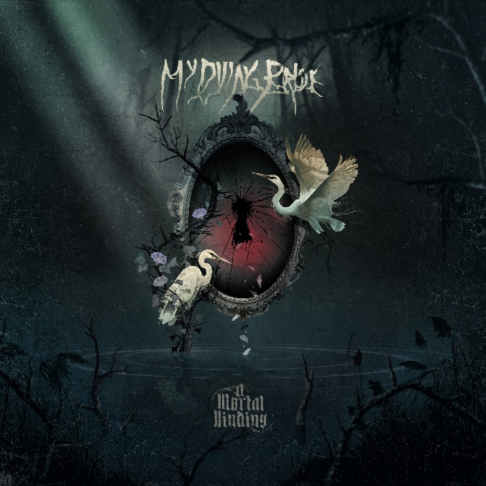

MY DYING BRIDE
‘A Mortal Binding’

OUT: April 19th 2024
Andrew Craighan | guitars  Aaron Stainthorpe | vocals  Lena Abé | bass  Shaun MacGowan | keyboards, violin  Dan Mullins | drums  Neil Blanchett | guitars | https://instagram.com/mydyingbride_official  https://twitter.com/Official_MDB  https://facebook.com/MyDyingBrideOfficial
Doom/death metal legends My Dying Bride are primed to unfurl their 15th album, A Mortal Binding, via Nuclear Blast. The much-anticipated follow-up to The Ghost of Orion (2020) finds the Yorkshire-based quintet—featuring a revamped lineup of now-permanent guitarist Neil Blanchett and the return of drummer Dan Mullins—delighting in anxiety, loss, and toil to resplendent effect. From the raw distress of “Her Dominion” and twisted horror of “Thornwyck Hymn” to the funerary violins of the 11-minute monolith “The Apocalyptist” and the classic-feeling “The 2nd of Three Bells,” A Mortal Binding is signature My Dying Bride. If Songs of Darkness, Words of Light (2004) elevated the Brits to new heights and A Map of All Our Failures (2012) expanded upon the group’s mid-tens grandeur, then A Mortal Binding stages My Dying Bride’s next exultant phase of elegiac misery.

“This album was much easier than The Ghost of Orion,” says vocalist Aaron Stainthorpe. “We were coming out of cancer with my daughter. That, naturally, was always playing on my mind throughout the recording. When the album was released, the world went into lockdown. Everything went dark. We didn’t know what to do next. Of course, we released the Macabre Cabaret EP, which was recorded at the same time as The Ghost of Orion, to keep interest up. We could finally gig a bit when the world opened up again. Only then could we begin, in earnest, the songwriting for A Mortal Binding.”

Actually, My Dying Bride guitarist Andrew Craighan ceaselessly writes. Even if the world was ending—and it felt like it was about to during the pandemic—the riff-master never sleeps. A Mortal Binding was the product of Craighan’s continued industry. While others binged Netflix, the My Dying Bride song-master noodled away, emailing his cleverest odes to bassist Lena Abé and new sideman Blanchett to chisel away at the foundations of what would become “Her Dominion,” “Unthroned Creed,” and “A Starving Heart.” Even though A Mortal Binding is barely out of the womb, Stainthorpe thinks Craighan’s already writing the follow-up, his largesse waiting for the right doleful moment to become reality. That he has Blanchett to spar with portends excellent things.

“I can imagine Andrew’s got hundreds more absolutely brilliant riffs on his computer,” Stainthorpe says of his long-standing cohort in sorrow. “It’s only when we’re at rehearsal that the songs come to life, though. This time, they did—more than I can remember. Neil didn’t have time to write for The Ghost of Orion, but on this album, he’s brought quite a few riffs to the table. When Neil and Andrew started firing riffs at each other, it was brilliant—the songs suddenly took on lives of their own. Riffs I had heard five times at home became monsters in the rehearsal room. Suddenly, everything was just gigantic—I loved it!”

Stainthorpe is renowned for his rich lyrical tapestry. Fittingly, Rolling Stone once opined that My Dying Bride, in all their gothic ornament, were ‘Bram Stoker’s Dracula for the ears.’ Others, including the group’s globe-spanning legion of enthusiasts, have felt similarly. Popular British magazine Kerrang! described The Ghost of Orion’s content as possessing “poignant gravity.” At the same time, Metal Hammer Germany couldn’t get enough of it, honouring its sonic and emotional heft with “best doom album of the year.” The lovefest will inevitably continue. The lyrics on A Mortal Binding will go down as some of Stainthorpe’s best, sharing the spotlight with dark treasures like “The Cry of Mankind,” “For My Fallen Angel,” “And My Father Left Forever,” and “Your Broken Shore.”

“The apocalypse is always on the horizon,” says Stainthorpe. “There’s always a bit of a tug at the heartstrings. Some of it’s written in a flamboyant style, which I like. I am old-fashioned. I like all poetry, the contemporary and the older stuff, but I’m a sucker for Lord Byron. He’s one of the great romanticists—I can’t help falling into that style now and again. That seems to please a lot of the fans. They love the aggressive apocalyptic stuff, too. They also love the whimsy and the more floral type of lyrics as well. I’m happy to do all that. That’s just the way I am.”

My Dying Bride hired The Ghost of Orion studio wizard Mark Mynett to produce, mix, and master A Mortal Binding. The group holed up at Mynett’s Mynetaur Productions (Paradise Lost, Rotting Christ) in Manchester, England, where they tracked nine songs—two unnamed for a future EP—non-consecutively from July to September. Although the striking “Her Dominion,” the withering movements of “Crushed Embers,” and the processional gray of “A Starving Heart” originated in the rehearsal room, they got their official My Dying Bride wings under Mynett’s expert tutelage. In fact, the group had so much faith in their producer that they also empowered him with the track ordering for A Mortal Binding, a task which Stainthorpe reveals is “always grueling.”

“He’s got the studio—he’s got all the gear,” Stainthorpe says. “We didn’t realise during the The Ghost of Orion recording that Mark is a professor at the University of Huddersfield. He has his office with ‘Professor Mark Mynett’ on the door. I remember saying to him, ‘You didn’t tell me you were a professor.’ He didn’t want to shout about it, apparently. For this album, at no point were we all together. I think the busiest it got, from what I hear, was Andrew and Neil were in the studio at the same time getting the guitar sound. That probably baffles some people. How could a band with six members never be in the studio simultaneously? That’s just the way it is these days. It was a relaxed, easy atmosphere even when I was doing my vocals.”

As My Dying Bride edge past their 33rd year, they’re aging gracefully, remaining as vital and heart-wrenching as ever. A Mortal Binding proves that not only with its depth on tracks like “Thornwyck Hymn” and “Her Dominion” but also its breadth with “The 2nd of Three Bells” and “The Apocalyptist.” The group plan a riotous (for them, anyway) 2024, appearing at festivals (Brutal Assault, Rockstadt, 70000 Tons of Metal, Maryland Deathfest) across Europe and North America. The flower withers once more on My Dying Bride’s A Mortal Binding…

